International Islamic University

Islamabad



Faculty of Management Sciences

Project: Principles of Microeconomics

Authors: Maryam Ajaz (64-FMS/BSBA/F22)

Samia Sajjad(66-FMS/BSBA/F22)​

Wajiha Anjum(72-FMS/BSBA/F22)​

Mahnoor(146FMS/BSPM/F22)​

Shawal Bibi(163-FMS/BSPM/F22)​

Submitted to: Miss Nazia Naeem

Table of Content

Introduction: 3

Analysis of the firm’s supply and demand: 6

a. Change in consumer’s income: 7

b. Change in price of competing products/ services: 8

c. Change in the number of Customer: 9

d. Change in technology: 10

e. Change in number of firms: 11

f. Change in the cost of production: 11

Analysis of the Price Elasticity of Demand: 13

Elasticity 13

Mid-Point Formula 13

Bibliography 16

# Introduction:

1. The business is a bakery called Werdaan, headquartered on the main GT road in Tarnol. It was established on 30th March 2002 and has two branches - one in Tarnol and the other in I-10 Markaz. There are 18 employees working for the firm, and its annual sales revenue is approximately between 30 to 40 lakhs.
2. Lotus and Kalakand Barfi are the most popular products of the bakery. People prefer and buy these two products the most, which contributes to the firm's revenue growth. As they have many regular customers, they do not offer discounts frequently. Discounts are given only through references or on special occasions like Iqbal Day, Pakistan Day, Independence Day, Resolution Day etc. when there are many orders. The price of a 2-pound Lotus cake is 1700, and a 1-pound cake is Rs 800. Kalakand Barfi costs 1500 rupees per 5 kg as 1kg burfi is Rs 300 and is available in both regular and discounted seasons.

**Day: 23 March [Resolution Day]**

Table 1 Products and their generated revenue

|  |  |  |  |  |  |  |
| --- | --- | --- | --- | --- | --- | --- |
| Product Name | Discount Price | Quantity Sold | Sales Revenues | Regular Price | Quantity Sold | Sales Revenues |
| Lotus Cake | 1500 | 10 Pounds [ 4 cakes] | 7500 | 1700 | 5 pounds [ 2 cakes] | 3400 |
| Kalakand Barfi | 250 | 8 kg | 2000 | 300 | 4 Kg | 1200 |

1. **Opportunity Cost:**

Suppose if we invest 50,000 in the training of our employees to increase the production process. As there are 18 workers in I-10 Markaz’s branch and they made 2 cakes per-day, and the sales revenue is (1700×2 )3400. After investment they can make 4 cakes per-day, and the sales revenue is (1700×4)6800.

On the other hand, if we invest 30,000 in new machinery which reduce Laboure work and make product faster. Now the firm produce 6 cakes per day and the sales revenue is [1700×6]10,200.

Hence, the opportunity cost is (10,200-68,00 =3400+ 2000 =23,400) = 23,400

Table 2 Opportunity Cost

|  |  |
| --- | --- |
| **Units of lotus cake [RS]** | **Units of kalakand burfi [RS]** |
| 17000 | 0 |
| 15300 | 600 |
| 13600 | 850 |
| 11500 | 1150 |
| 10200 | 1200 |
| 8500 | 1500 |
| 6800 | 1800 |
| 5100 | 2050 |
| 3400 | 2350 |
| 1700 | 2550 |
| 0 | 2100 |

Figure 1 Trade off graph

1. Examples of solving the problem of Scarcity

• If the firm faces a problem of shortage of raw materials, they resolve it by taking time from the customers and ordering necessary items from the industry. In this way, the customers are satisfied, and the work is completed.

• If on the spot the wanted product is not available for the customer then they use to satisfy the customer by providing him/her the best alternative or other similar product.

# Analysis of the firm’s supply and demand:

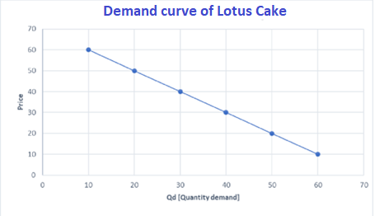

Figure 2 Demand Curve of lotus cake

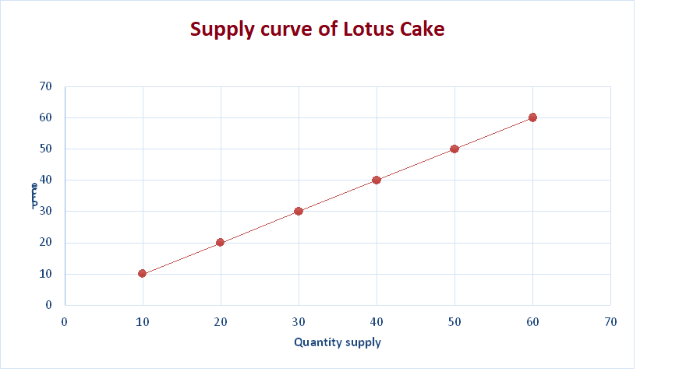

*Figure 3 Supply curve of Lotus cake*

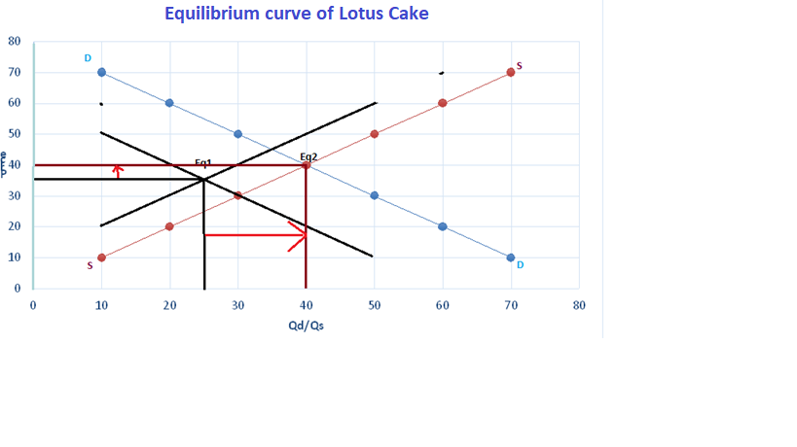

Figure 4 Equilibrium curve of lotus cake

## Change in consumer’s income:

Increase in consumer income there is no affect in the products. This product is called Normal goods. Secondly, income has been decreased in Pakistan over the year. Overall products demand has decreased but there is no change in supply. So, this is normal goods. Overall, change in consumer income can significantly impact the demand for products, and producers need to be aware of these changes and adjust their prices, marketing strategies, and production levels accordingly.

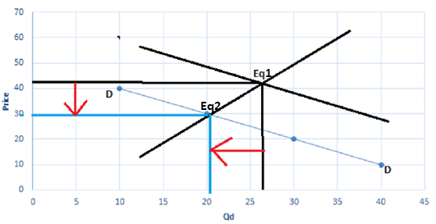

Figure 5 change in consumers income

## Change in price of competing products/ services:

Tehzeeb is the competitor of Werdaan. Lotus cake substitutes for marble cake and there is no effect on competitor prices because they built strong customer relationships. Customer fully trusts on their products. So, the demand is high, and supply will also be high. A price change in a competing product can create an opportunity for the seller of the original product to increase their price.

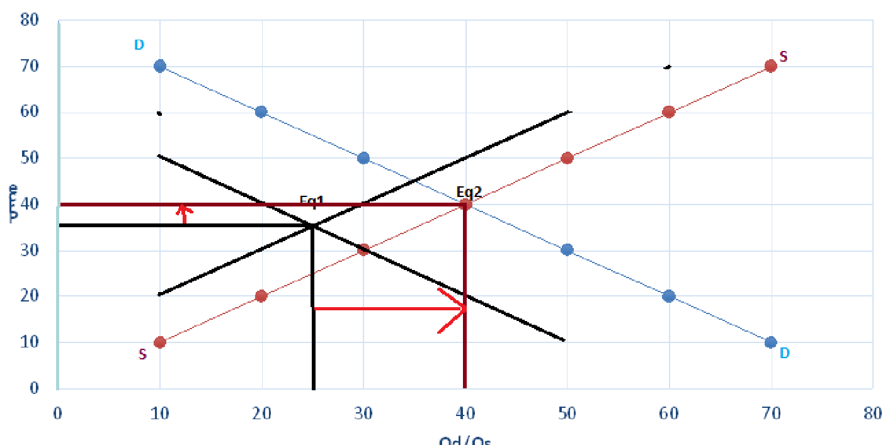

Figure 6 Change in competitors’ price

## Change in the number of Customer:

Mostly Adult consumers can purchase products Age (18 to 25) both gender male and female and income maximum (20k to 50k) mostly regular customers order the products in International Islamic university. In recently 1 pound cake order from IIUI. Lotus cake and marble cake demand are high sometime these cakes price is high but there is no change in demand because mostly customers prefer those cakes so, supply is high but demand more than high.



Figure 7 Change in number of customers

## Change in technology:

Werdaan the use of new technology. They introduced delivering the products. Customers can easily order the products and enjoy them. Through new technology the demand is increase and supply will also be increased.

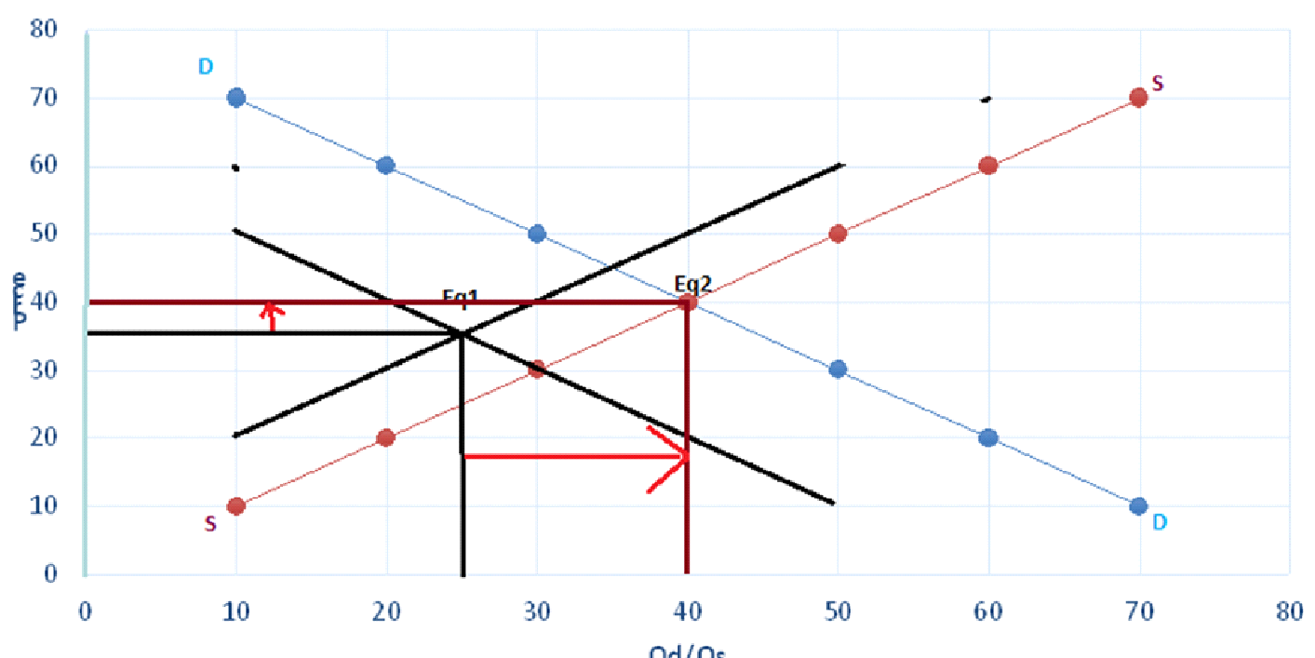

Figure 8 Change in technology

## Change in number of firms:

There is only one bakery in the one place [I-10 Markaz]. If new bakery is entered in the market with the same product i.e., Lotic cake, this would decrease the customer of this bakery, as a result the demand will be decreases. As in this case the supply is directly related to the demand of cake, so it would also decrease and there is no change in the price.

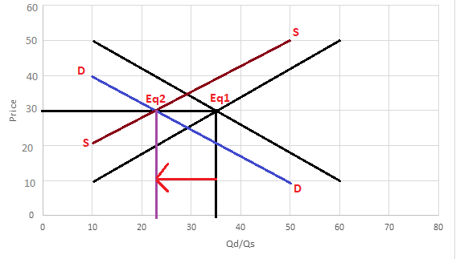

Figure 9 Change in number of firms

## Change in the cost of production:

As production [cost of raw material] is increased, it leads to decrease in supply as firm find it less profitable to produce lotus cake. This could lead to increase in price of cake, as a result the demand of lotus cake is decreases.

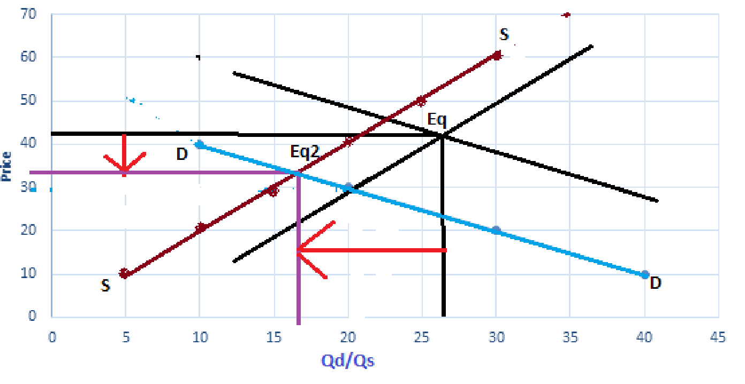

Figure 10 Change in cost of production

# Analysis of the Price Elasticity of Demand:

## Elasticity

**a.** The product is Lotus cake. Lotus cake is more-elastic because if the price of lotus cake is increases there is great change in quantity demand.

**b.**

Table 3 Elasticity of products

|  |  |  |  |  |  |  |
| --- | --- | --- | --- | --- | --- | --- |
| Product Name | Discount Price[P1] | Quantity Sold [Q1] | Sales Revenues | Regular Price[P2] | Quantity Sold [Q2] | Sales Revenues |
| Lotus Cake | 1500 | 10 Pounds [4cakes] | 7500 | 1700 | 5 pounds [2 cakes] | 3400 |
| KalaKand Barfi | 250 | 8 kg | 2000 | 300 | 4 Kg | 1200 |

## Mid-Point Formula

**a. Lotus Cake**

PED =percentage of quantity demand / percentage change in price

Q1 =10

Q2 = 5

P1 = 1500

P2 = 1700

PED = (Q2 -Q1/Q1) ×100 ÷ (P2-P1/P1) ×100

= (5-10/10) × 100 ÷ (1700-1500/1500) ×100

= -50 ÷ 13.33

PED= -3.7 > 1 [ Good is more elastic]

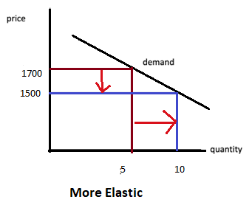

Figure 11 Elasticity of Lotus cake

**b. Kalakand Barfi**

Q1 = 8

Q2 = 4

P1 = 250

P2 = 300

PED= (Q2 -Q1/ Q1) × 100 ÷ (P2 – P1 /P1) × 100

= (4 -8/8) × 100 ÷ (300 -250 /250) × 100

= -50 ÷ 20

PED= - 2.5 > 1 [ More Elastic]

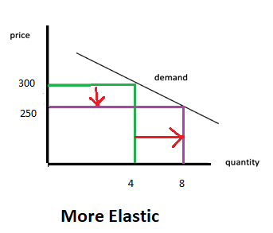

Figure 12 Elasticity of kalakand

# Bibliography

Self-collected data from [Werdaan Bakers.](https://www.facebook.com/WerdaanBakers/)